  - Vision for voice diary/feedback tool:
    - Collect feedback from users using voice as an input. Regular speech -> structured data
      - Categorize feedback
      - Summarize key points
      - Simple dashboard for overall view
        - 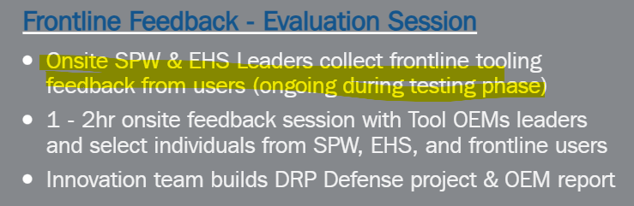
      - Insights across projects and teams (tips, use-cases issues etc.)
    - Create PTPs, JHA or other documentation using feedback input or separate recordings before use of chosen tools
      - 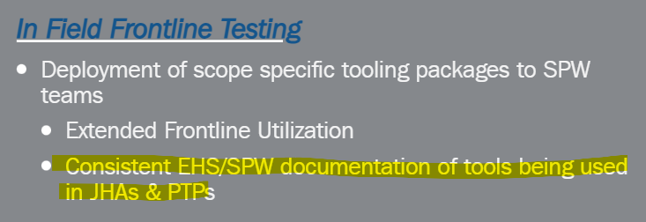
      - Easy document creation and standardized workflows
    - Future:
      - Automatically pick "best tool for the job" through a standardized process informed by the DPR Defense Guidelines
        - Use JHAs or PXPs as input as well as any other details required (region, project schedule, questionnaire etc.)
      - Create tool procurement inquiry for OES
      - Provide field teams with cost information and lead times per OES input
      - Gather continued feedback from users and highlight findings within regions or across tool types
        - Usage data
        - Injury rates
        - Tips

  - UI / Design Brainstorm
    - Power Tools from
      - DeWalt
      - Milwaukee
      - Hilti
      - Makita
    - Login - Project, User + Activity Information
    - Power Tool Selection
      - Brand -> Model -> Features, Best Practices etc.
        - 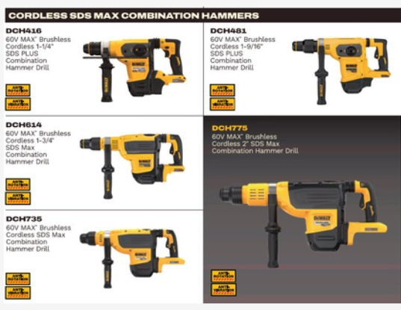
      - Pre-feedback questionnaire? Prior experience, perceived safety, productivity etc.
    - Feedback
      - Standard questionnaire
      - Free-form
      - Both
    - Dashboard
      - User -> Daily Summary and insights
      - Admin -> Regional or project based team summary, Plus/Delta
      - Post-use perceived safety, productivity review

  - Design & Tech:
    - Webapp with mobile friendly UI
    - Could be made into an easier format for field if app isn't desired.
      - However, text or Telegram bots might be more difficult if images etc to be involved
    - Webapp for admin dashboard
    - Database? Does this need to be on the DPR side?
    - Transcription Tech- Currently using OpenAI whisper
    - Categorization - Claude or OpenAI or keywords?
      - Positive vs negative
      - Productivity, safety, effort, comfort, adaptability

